General & Miscellaneous
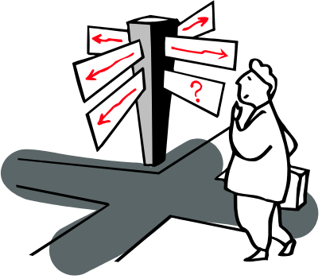

I’ve always found it difficult to talk about myself. In fact, I think that some of the most difficult experiences of my life have been those of trying to write about myself, whether it be for a class, a college or scholarship application, my national merit essay, or something for a contest (such as Page One). I’m not sure exactly why this is - perhaps it just doesn’t seem humble. At any rate, in order to spare myself the trouble of writing some sappy statement about myself, I instead decided to simply include something I had already been forced to write - my Goals Statement from Senior Composition - as well as several personality analyses that I took over the internet. This way, I’ve left it up to you to draw your own conclusions. By the way, I’ve also included several miscellaneous works (mostly journal articles) that I hope will help you to formulate those opinions. Of course, I admit that your welfare was not my only reason for including them here. The truth is that I simply couldn’t find a place for them anywhere else in my portfolio.

